**2nd Semester: 24-25 School Year Assignments**

**Week 10: March 10-14**

**Tuesday: 3/11/25**

1. **Videos:**

[https://youtu.be/tm7faM0-iKQ?si=YzFfTtTZU_44Szhr](https://nam11.safelinks.protection.outlook.com/?url=https%3A%2F%2Fyoutu.be%2Ftm7faM0-iKQ%3Fsi%3DYzFfTtTZU_44Szhr&data=05%7C02%7CThomaDa%40BOE.richmond.k12.ga.us%7C8eda370f3d3f43bbfa2808dd608eaafc%7C30b22d4073624f1783a92530927b6f65%7C0%7C0%7C638772888066674895%7CUnknown%7CTWFpbGZsb3d8eyJFbXB0eU1hcGkiOnRydWUsIlYiOiIwLjAuMDAwMCIsIlAiOiJXaW4zMiIsIkFOIjoiTWFpbCIsIldUIjoyfQ%3D%3D%7C0%7C%7C%7C&sdata=%2FnENUk05dwbgGgBIBQK0l5C9llqAx3udA24vHjOToM0%3D&reserved=0) (disc slam)

[https://youtu.be/qPoXX1z_gMU?si=KUW5mxOsi_-J5rDb](https://nam11.safelinks.protection.outlook.com/?url=https%3A%2F%2Fyoutu.be%2FqPoXX1z_gMU%3Fsi%3DKUW5mxOsi_-J5rDb&data=05%7C02%7CThomaDa%40BOE.richmond.k12.ga.us%7C8eda370f3d3f43bbfa2808dd608eaafc%7C30b22d4073624f1783a92530927b6f65%7C0%7C0%7C638772888066692261%7CUnknown%7CTWFpbGZsb3d8eyJFbXB0eU1hcGkiOnRydWUsIlYiOiIwLjAuMDAwMCIsIlAiOiJXaW4zMiIsIkFOIjoiTWFpbCIsIldUIjoyfQ%3D%3D%7C0%7C%7C%7C&sdata=mjTH1sUaU7MkZNTA6WZ1DQhNurRi%2FwyPf1OmbG%2BDXho%3D&reserved=0) (corn hole)

Rules may be slightly different in the video but I am using them so that they get an understanding of how to play in general.

On a sheet of paper,

1. Write your name and your partner's name (if you do not yet have a partner, write your name & you will be put in a group)

Respond to the following while the videos are playing:

* 1. Objective of the game
  2. How to score (write down point values and how to earn each)
  3. Draw or describe the game set up (where players stand, where boards/baskets are, how far apart are they, etc)

1. Submit in Canvas or to your teacher (ask Coach which form of submission for her class)

**Monday: Asychronous**

**Week 9: March 3-7**

**Student Reading Document: Agility, Speed, and Fitness**

*READ information then answer review questions using the information provided in the reading

**1. Understanding Agility and Speed**

**What are Agility and Speed?**

* **Agility** is the ability to change the direction of your body quickly while maintaining control. It is a crucial skill for many sports like basketball, soccer, and football because players need to react quickly to opponents and adjust their movements in unpredictable situations.
* **Speed** is the ability to move quickly over a set distance. Speed is essential in activities like sprinting, soccer, and football, where the goal is to reach a target or goal as quickly as possible.

**The Five Components of Fitness**

The five components of physical fitness are key to overall health and athletic performance. Each component plays a role in improving your agility and speed:

1. **Cardiovascular Endurance**: The ability of your heart and lungs to supply oxygen to your body during physical activity. It is vital for sustaining speed and stamina during physical exercises like running or jumping.
2. **Muscular Strength**: This is the ability of your muscles to exert force. Strong muscles help you change direction quickly in agility drills and provide the power needed for speed.
3. **Muscular Endurance**: The ability of your muscles to perform repeated movements without tiring. When performing drills like ladder exercises, your muscles need endurance to maintain quick footwork.
4. **Flexibility**: Flexibility refers to the range of motion in your joints and muscles. Having good flexibility allows you to move fluidly and reduce the risk of injury during agility and speed exercises.
5. **Body Composition**: This refers to the amount of fat compared to lean muscle in your body. Athletes with a lower body fat percentage and more lean muscle typically have greater agility and speed.

**Phases of a Workout**

A workout typically consists of three phases:

1. **Warm-up**: This phase is crucial for preparing your body for exercise. It increases blood flow to your muscles and raises your heart rate. It can include activities like light jogging, dynamic stretching, or bodyweight exercises.
2. **Main Workout**: This is the core part of the workout, where you perform drills to build agility, speed, and strength. It is essential to focus on proper form during these exercises to avoid injury and gain the most benefit.
3. **Cool-down**: After your main workout, the cool-down phase helps your heart rate return to normal and reduces muscle tightness. It can include static stretches and deep breathing exercises.

**2. Benefits of Agility and Speed Exercises**

Speed and agility exercises have many benefits:

* **Improved cardiovascular health**: These exercises get your heart pumping, improving your overall heart and lung health.
* **Enhanced reaction time**: You become quicker at responding to changes in direction or speed, which is important in sports and everyday activities.
* **Better balance and coordination**: Agility exercises help you control your body, improving your ability to maintain balance in dynamic environments.
* **Increased stamina and endurance**: Speed and agility exercises build your endurance, helping you perform activities for longer periods without getting tired.
* **Reduced risk of injury**: Regular training improves flexibility, joint stability, and muscle strength, lowering the likelihood of injury.

**3. Proper Form for Throwing a Frisbee**

Frisbee throwing involves a few key steps to ensure proper technique and accuracy:

* **Grip**: Hold the frisbee with your thumb on top and your index finger along the edge. Your remaining fingers should rest underneath the frisbee for stability.
* **Posture**: Stand with your feet shoulder-width apart. Bend your knees slightly for better balance.
* **Throwing Motion**: As you prepare to throw, extend your arm back and rotate your body for power. Snap your wrist to give the frisbee its spin, which is important for stability in flight.
* **Accuracy**: Focus on guiding the frisbee toward your target without trying to catch it. The frisbee should be thrown with enough force and spin to travel in a straight line toward the target.

**Agility, Speed, Fitness, and Frisbee Review Questions: Answer in complete sentences by restating the question in your answer for FULL CREDIT**

**Learning Target 1: I can relate agility and speed exercises to the five components of fitness along with the phases of a workout.**

1. What is agility, and why is it important in sports?
2. What is the difference between agility and speed?
3. Name the five components of fitness and briefly describe each.
4. How do agility and speed exercises help improve cardiovascular endurance?
5. Why is flexibility important for agility and speed training?
6. What is the purpose of a warm-up before doing agility and speed exercises?

**Learning Target 2: I can explain the benefits of speed and agility exercises.**

1. What are two benefits of speed and agility exercises for athletes?
2. How do speed and agility exercises improve balance and coordination?
3. In what ways can agility and speed exercises reduce the risk of injury?
4. How can speed and agility exercises improve your endurance?

**Learning Target 3: I can demonstrate the proper form and technique for throwing a frisbee and guiding it to a target without catching it.**

1. What is the proper grip for throwing a frisbee?
2. Explain the throwing motion for a frisbee.
3. Why is wrist snap important when throwing a frisbee?
4. What should you focus on when throwing a frisbee to a target without catching it?

**Week 7: Feb 17-21**

**Monday: 2/17/25 President’s Day**

**Tuesday:2/18/25 Asynchronous: Makeup Day**

**Wednesday: 2/19/25-2/20/25**



**Week 6: Feb 10-14**

**Thursday: 2/13/25**

Black Athletes that Impacted various sports video

<https://www.youtube.com/watch?v=hRmgJfxm28s>

Classwork:

1.list three athletes from the video (choose those you are unfamiliar with)

2.**For each athlete do the following**

a. name the sport they impacted

b. list one accomplishment in that sport

c. In at least two complete sentences, explain how at least 2 of the 5 components of fitness are essential to the athlete’s high performance.

3. Upload in Canvas

**Week 2: Jan 13-17**

**Learning Targets:**

1. **I can demonstrate my understanding for the phases of a workout**
2. **I can demonstrate the proper technique and max out for bench press and spotting for bench press, squat burn out or max, core burn out (crunches/toe touches)**
3. **I can list and explain the five components of fitness**

**Monday Jan 13**

1. **Warmup: jog, high knees, butt kicks, shuffle, high skips, arm circles, & static stretches**
2. **Class discussion phases of workout & 5 components of fitness**
3. **Importance of flexibility video**
4. **Partner stretching pick 3 flexibility exercises from the chart & hold for 15 seconds**
5. **Share out-polleverywhere/quizziz and/or padlet**

**Tuesday Jan 14**

1. **Warmup: hallway- jog, high knees, butt kicks, shuffle, high skips**
2. **Muscular Endurance - 30 seconds x 2**
   1. **Push ups**
   2. **Bleacher jumps**
   3. **Tricep dips**
   4. **Squats**
   5. **Planks**
   6. **Crunches**
   7. **Bridges**
3. **Flexibility workout/cool down**
   1. **Importance of flexibility and muscular endurance**

**Wednesday Jan 15**

1. **Warmup: same as previous days this week**
2. **Squat spotting video**
3. **Squat Burn out or Max out in groups**
4. **Jump Rope and/or Jo/g 5 minutes (pacer test distance)**
5. **Stretch**
6. **Circuit Training: renegade push ups, toe touches, shoulder press, lunges,**

**Thursday Jan 16**

1. **Warmup: same as previous days**
2. **Flexibility review of importance & exercises**
3. **Speed & agility relay**
4. **Medicine ball workout as a group (in gym)**
5. **Cool down**

**Friday Jan 17**

1. **Nearpod review and assessment**
2. **Free Play if time permits**

**Week 1: January 6-10**

**Jan 7:**

1. **Warmup: attempt jump rope**
2. **Workout: 2 x 8**
   1. **Bench: bar & low weight**
   2. **Bicep curls**
   3. **Squats with dumbbells**
   4. **Lunges**
3. **Cool down: stretch**
4. **GYM**

**Jan 6**

1. **Weight Training Benefits Video:** [**https://www.youtube.com/watch?v=nQOzqFRrboY**](https://www.youtube.com/watch?v=nQOzqFRrboY)
2. **Bizarre Aftermath of Supersize me:** [**https://www.youtube.com/watch?v=25gdst3PLnw**](https://www.youtube.com/watch?v=25gdst3PLnw)

**Warmup:**

1. **PE Chef Components of Fitness Video:** [**https://www.youtube.com/watch?v=vYjqXZsU5lk**](https://www.youtube.com/watch?v=vYjqXZsU5lk)
   1. **Students attempt to identify the correct component based on exercise cold call or volunteers**
2. **Coach Check schedules & sign off**

**Classwork:**

1. **Syllabus Review how to access & info**
2. **Worksheet: Components of a Questions (explain to students that this is due by Thursday this week in presentation form with group video explaining and demonstrating each)**
3. **Define each component of a workout (warm-up, main activity, cool-down).**
4. **Provide two examples of activities for each component.**
5. **Explain why each component is essential to a workout.**
6. **Write a sample workout plan (include all components).**

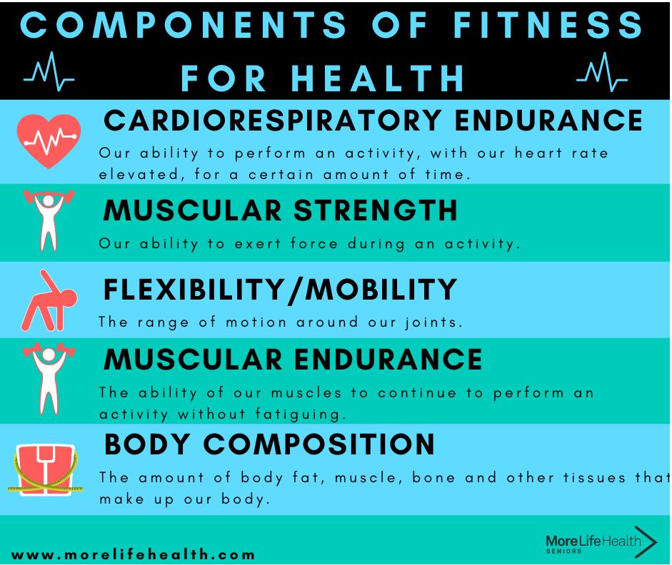

**Exit Assessment Questions (Multiple Choice & Short Answer)-Think-Pair-Share**

1. **What is the primary purpose of a warm-up?  
   a) Build muscle  
   b) Prepare the body for exercise  
   c) Increase soreness  
   d) Burn calories**
2. **Which of the following is NOT part of a cool-down?  
   a) Gentle stretching  
   b) Breathing exercises  
   c) Sprints  
   d) Mindfulness activities**
3. **Short Answer: Describe how you can apply the components of a workout to improve your fitness routine.**

**Rubric for Grading the Worksheet and Assessment:**

* **Understanding of each component: 10 points**
* **Clarity and relevance of examples: 10 points**
* **Completion of workout plan: 10 points**
* **Total: 30 points**

**Week 4:**

**Pickleball Worksheet**

**Rules**

1. **How do you start a game of pickleball?**
2. **What is the double-bounce rule?**
3. **Explain the role of the non-volley zone (kitchen).**

**Techniques**

1. **Describe the proper way to serve in pickleball.**
2. **What is the difference between a forehand and backhand stroke?**

**Skills**

1. **List two strategies for improving your accuracy when hitting the ball.**
2. **Why is communication important in doubles play?**

**Playing Floor**

1. **Label the following on the court diagram: baseline, service area, non-volley zone, centerline.**
2. **Draw arrows to show where players should stand during a serve in doubles play.**

**Assessment for Coaches:**

**Exit Quiz Questions (Multiple Choice & Short Answer)**

1. **What is the purpose of the non-volley zone?  
   a) To avoid serving faults  
   b) To prevent volleys close to the net  
   c) To mark the opponent's serving area  
   d) To divide the court**
2. **What is the correct serving position in doubles?  
   a) Behind the non-volley zone  
   b) Anywhere on the court  
   c) Behind the baseline within the service area**
3. **Short Answer: Describe one skill or technique you improved during the week and how it helped your game.**